Exercise 28: Upload and Download file

Objective
Uploading and downloading files are essential features for many web applications. Node.js, with the help of popular libraries like multer and express, makes it straightforward to implement these functionalities. In this exercise, you’ll learn how to create a simple file upload and download system using Node.js and Express.

Exercise
- Copy node-https app and rename https-upload-download

Upload
- Change file uploadRouter.js
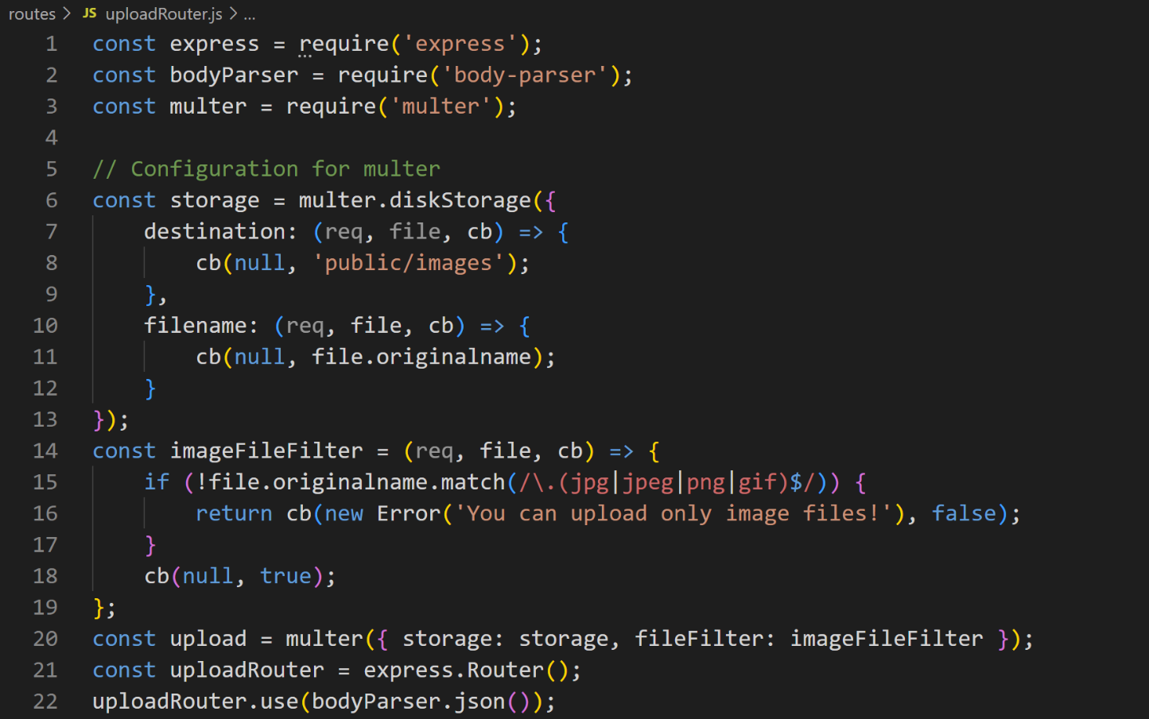
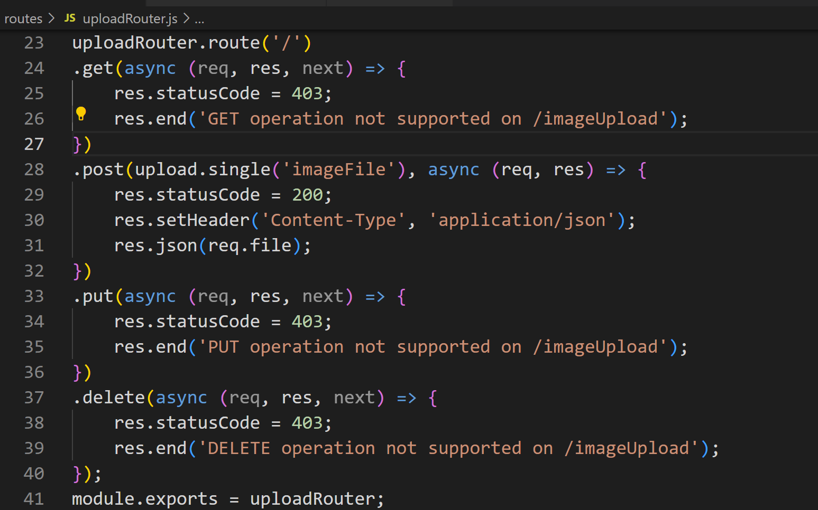
- Test with postman
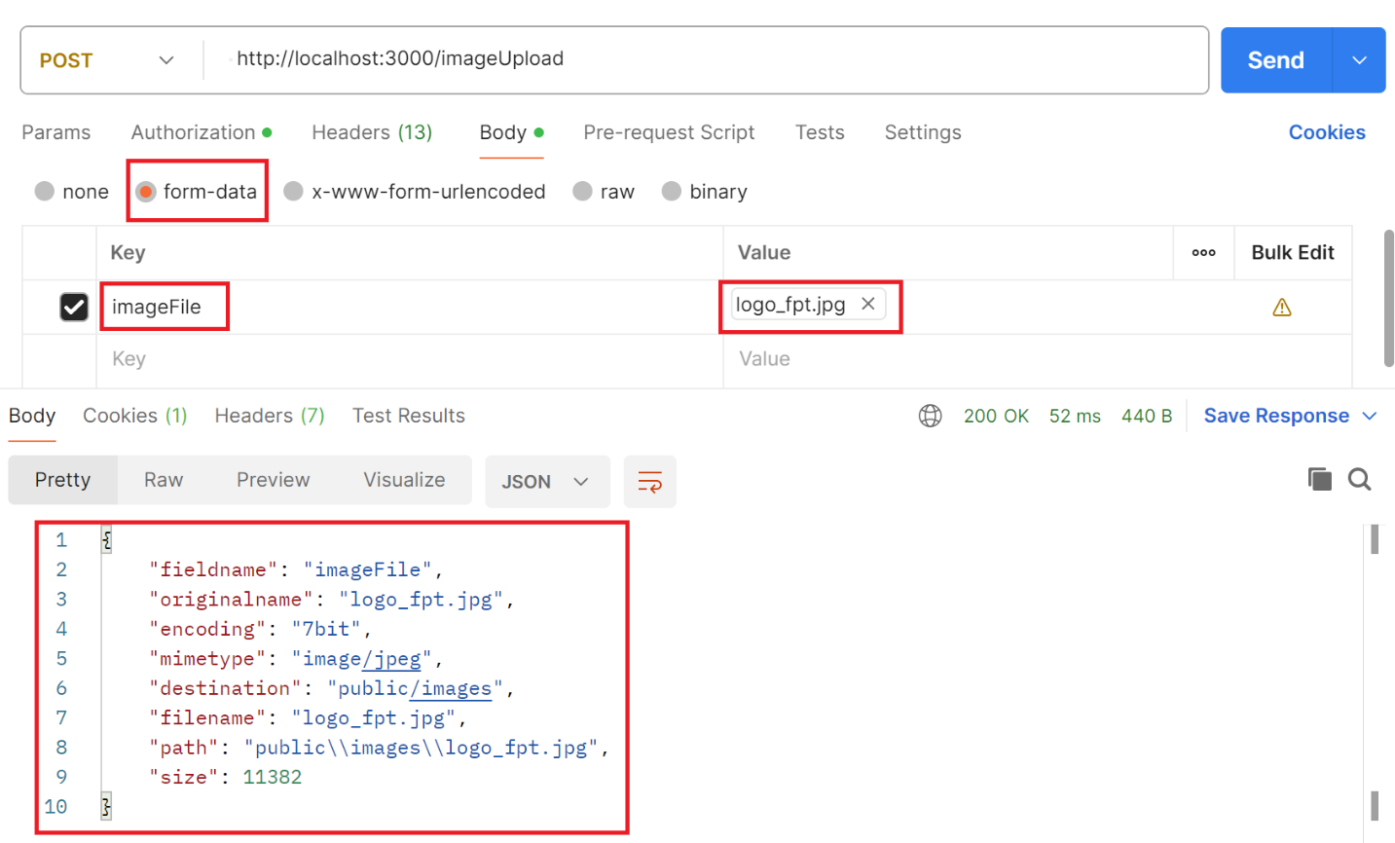
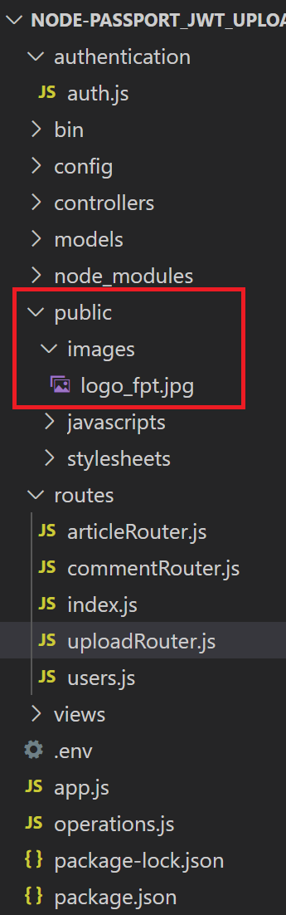

Download
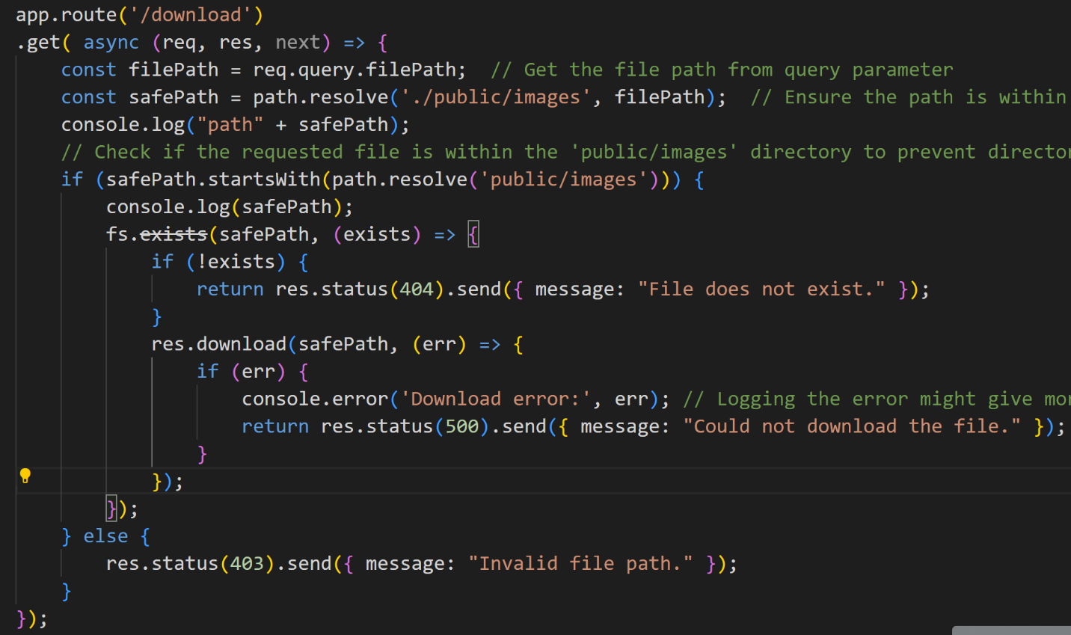
- Test with postman
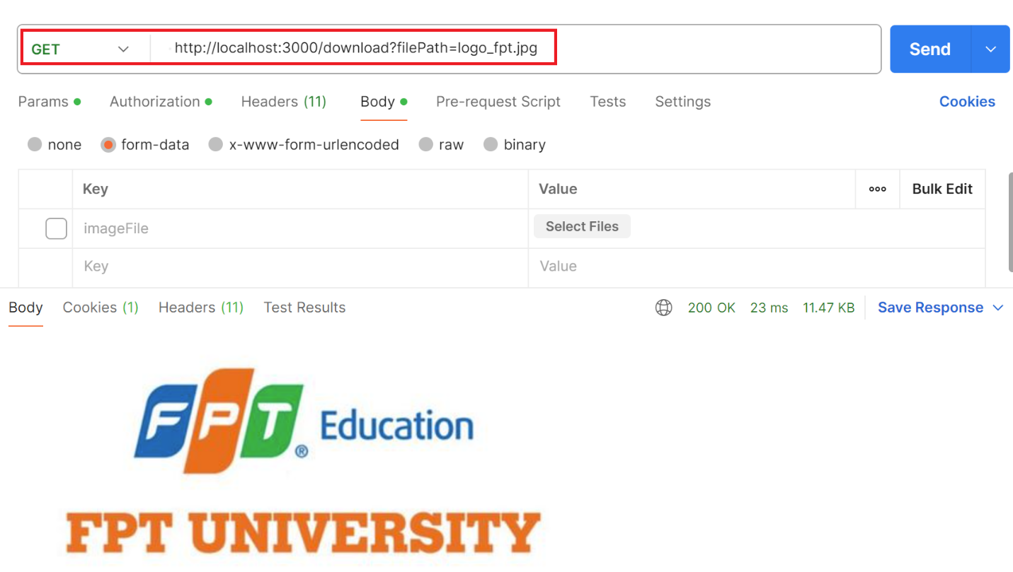

Conclusion
By completing this exercise, you have implemented file upload and download functionality using Node.js, Express, and Multer. This covers essential aspects of many web applications, such as handling user-generated content or serving static files. You can expand this by integrating security measures, user authentication, and proper error handling for robust file management.

